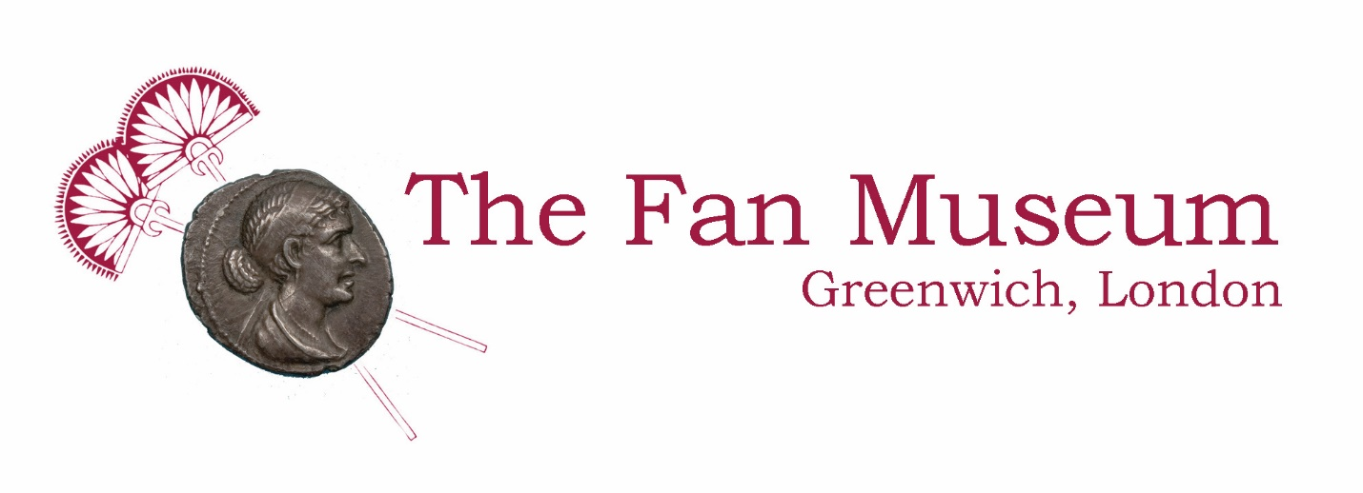

Orangery Hire Booking Form

Type of Function:
Number of Guests:
Preferred Date:
Preferred Time:
Total Hours:
Contact Name:
Email Address:
Telephone Number:
Full Address:

Details (refreshments, corkage, additional comments):

Please confirm you understand and agree to the terms & conditions enclosed:
Name: |  | Date:

Orangery Hire Terms & Conditions

- This form applies to non-museum-related events (i.e. baby showers, receptions, birthday celebrations etc.) on Monday, and Wednesday to Saturday.

- The hire entitles use of the Orangery for 90 minutes or more.

- A deposit of 1/3 of the final amount must be paid in order to confirm the booking.

- We require all hires to be prepaid at least one week prior to their function.

- Price List:

Orangery Hire
Orangery Hire | £150.00 ph (incl. VAT)
Refreshments
Coffee / Tea & Biscuits | £4.00 pp
Afternoon Tea:  scones, cream, jam and cakes (Carrot Cake and a choice of Lemon Drizzle and Salted Caramel Chocolate Brownie) | £9.00 pp
Afternoon Lunch:  scones, cream, jam, cakes (as above) and sandwiches | £12.00 pp
Corkage | £5.00 per bottle

Finding Us

Nestled in the heart of historic Greenwich in South East London, the museum is easily reached by public transport or car.

Connecting bus route numbers: 177, 180, 188, 199, 286, 386
Cutty Sark DLR
The Fan Museum
Greenwich National Rail

